To Our Potential Advertisers:

We are Virginia and West Virginia’s own, Disabled Dealer Magazine. Our mission is to bring people with disabilities and the elderly complete access to new and pre owned adaptive equipment, services, resources and events throughout Virginia and West Virginia. We take pride in our distribution. The following is listing of people and organizations that receive our magazine on a monthly basis:

● Hospitals
● Rehabs
● Support Groups
● Retirement Communities
● Subscribers
● Disability Clubs
● Wheelchair Sporting Events
● Expos
● Conferences
● Outreach Programs
● Resource Centers
● Independent Living Centers
● Outpatient Clinics
● Vocational Rehab Depts.
● Hospices
● Medical Equipment Companies
● State Agencies for the Aged and Disabled
● Non-Profit Organizations
● Targeted Mailing Lists that go out Direct Mail

Advertising in Disabled Dealer is more than just a display ad. We receive numerous phone calls from individuals looking for specific items and naturally we refer them to our advertisers in their area. We are a Magazine / Referral Service.

As always, at no extra charge, you get:
Guaranteed distribution, Honest Rates, Unparalleled Service, and Unequaled professionalism!

Thank you again for your interest in Disabled Dealer Magazine of Virginia and West Virginia!

New & Pre-Owned
Wheelchairs &
Scooters!
Recreational
Equipment!
Lifts

Expos & Events

Adaptive Medical
Equip
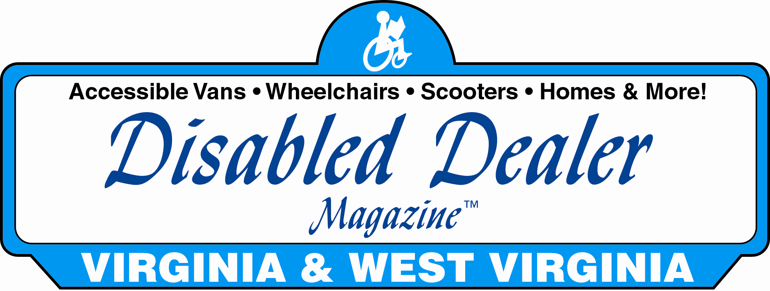
Wheelchair
Accessible Vans!

BUY - SELL - TRADE
VIRGINIA & WEST VIRGINIA’S # 1

ADAPTIVE
RESOURCE
GUIDE

Disabled Dealer of Virginia & W. Virginia
2075 W Main Street
Waynesboro, VA. 22980
Toll Free: (800) 420-6470
Fax: (540) 941-3517
E Mail: ddmofva@ntelos.net
www.disableddealer.com

BUY - SELL - TRADE
Deadlines
Call for deadlines

Magazine Format
40 lb Newsprint with full color and B & W
Pages throughout

Artwork Specifications
Electronic Art-Disabled Dealer Magazine™ is created on Macintosh computers, using Quark Xpress 4.0 Adobe Illustrator 7.0 and Adobe Photoshop 5.0. If your ad was created in any of these programs (including earlier versions) or is a program that will allow you to save it as a 300 dpi. EPS or TIFF document. Send electronically to ddmofva@ntelos.net include all fonts and graphics used in the ad. Include a hard copy of all B & W ads or match print of 4/c ads. For questions regarding compatibility, call 800-420-6470. PC files will not be accepted.

Photo Ads Sent Electronically: Pictures need to be submitted as JPEG, (Maximum Resolution), TIFF of EPS (300 dpi), at least 3.5 x 2 inches in size. If submitting an image from the internet, be sure it meets these specifications, 72 dpi images (the normal resolution for internet images) will not reproduce well in print.

Film-B/W: Right-reading, emulsion-side down negatives; 85-line screen. Film must indicate bleed and trim as well as center marks. Each color negative should be marked for color.

BLACK & WHITE

FULL COLOR

Full Page 700 675 875

Back Cover 900 875 850

Inside Front 900 875 850

½ Page 425 400 375

Links: $100 per year

Banners: $200 per month
Mission Statement

Our mission is to bring people with disabilities and the elderly complete access to new and pre-owned adaptive equipment, services, resources and events throughout Virginia and West Virginia.

About The Founders

Rob Smith has been a quadriplegic since 1980 as a result of a diving accident while in the service. Robert served eight years in the armed forces and retired as an E-6 Staff Sergeant. He is now a lifetime member of the P.V.A., the D.A.V., and is a member of the Hillsborough County Mayor’s Alliance for People with Disabilities.

Stella Smith, a Registered Nurse, has been married to Robert since 1991. She brings her five years experience in spinal Cord Injury to Disabled Dealer Magazine. Since the V.A, she has worked as a Community Health Nurse with the Governors Healthy Start Program.

Oliver O’Riordan serves the Disabled Dealer organization in a number of ways. His mainstay is overseeing general management duties for DDM Graphics. He also assists Disabled Dealer Enterprises, Inc. In the sales and Graphics sector of the initial training process. “Our mission is to bring people with disabilities and the elderly complete access to new and preowned adaptive equipment, services, resources, and events throughout the country.”
3x 6x 12x
Full Page 500 475 450

½ Page (H or V) 300 275 250
¼ Page 175 150 130

1/8 Page 85 80 75

2075 W. Main St. – Waynesboro, VA 22980 – Toll Free: (800) 420-6470 – Fax: (540) 941-3517 – Email: ddmofva@ntelos.net – Website: disableddealer.com
3x 6x 12x

